Form for Permission to Solemnize a Marriage

Convocation of Episcopal Churches in Europe

Name of Priest:
Parish or Congregation:
City & Country:
Date of Proposed Solemnization: _________________________

Name:
Number of Marriages: ___________ Date(s) of Previous Marriages

Names and Ages of Children from Previous Marriages None

Child Support Paid in Full? Yes No (If NO, explain why not in a separate letter.)
Name:
Number of Marriages: ___________ Date(s) of Previous Marriage(s)

Names and Ages of Children from Previous Marriage(s)

Child Support Paid in Full? Yes No (If NO, explain why not in a separate letter.)
I have ascertained by examination of the relevant documents that the unions of

___

has/have been legally dissolved.

(If a judgment of nullity alone is requested, send in only the first page, duly signed.)
Circle the appropriate response:

Yes No N/A I have ascertained that the couple has already been married civilly (if national law requires it prior to religious solemnization).

Yes No I have or will fulfill the canonical requirements for pre-marital conversations, including discussion of marriage as a sacrament, family issues, communication skills, budgeting and financial planning, and sexuality. The couple has signed the Declaration of Intent required by Canon I:18.4.

Yes No I have asked the couple whether another priest of this Church has declined to solemnize the marriage. If so, I have asked that priest to discuss the grounds for refusal.

Yes No I have ascertained that at least one person is a baptized Christian.

Yes No I am reasonably assured that the couple, or least one person, will continue as a member in a congregation of the Christian Church.

Yes No I believe the marriage of this couple is well-intended and that the reasons for previous failure have been realistically addressed.

Yes No The date of the proposed marriage is at least 30 days from the receipt of this petition to solemnize it. (If not, explain why in a separate letter.)

Yes No I have enclosed the responses from the divorced person(s) with this petition. (If not, explain why in a separate letter.)

Yes No I will solemnize this marriage if permission is given.

(If one person or both persons has been divorced more than twice,
please speak to the Bishop personally.)

I request permission to solemnize the marriage of _________________ and __________________
on ______________________, 201__, and will notify the Convocation Office when I have done so.

Signed, _____________________________

Date: _____________________________
Revised January 2016
THE CONVOCATION OF EPISCOPAL CHURCHES IN EUROPE

Episcopal Church USA within the Anglican Communion

The Right Reverend Pierre W. Whalon, Bishop in Charge

Dear sister or brother,

As you know, Episcopalians look to their bishops to provide a special ministry of oversight for them. Among other duties, this means taking the responsibility before God for giving permission for a priest to solemnize the marriage of someone who has been previously married.
I respectfully ask that you write a letter to me to form part of your priest’s request for permission to proceed with your re-marriage. I will hold this letter, as well as the other materials your priest will submit, in the strictest confidence.

Please feel free to make your letter as long or as brief as you like, handwritten or typewritten. (Besides English, it could be in French, German, Spanish or Italian.) In any event, try to help me learn something of the following:

- the reasons for the failure of the previous marriage(s)
- what counseling took place, if any, to try to save the marriage
- what spiritual regeneration and growth you have experienced since the divorce
- what grounds you have for confidence in the success of the intended marriage

You may give your letter to your priest for inclusion in the request for permission, or you may mail it directly to me, marked “personal and confidential,” to the address shown below. Please ensure that you include your return address. (If you mail it directly to me, please let your priest know that you have done so.)
Thank you in advance.

Yours in Christ,
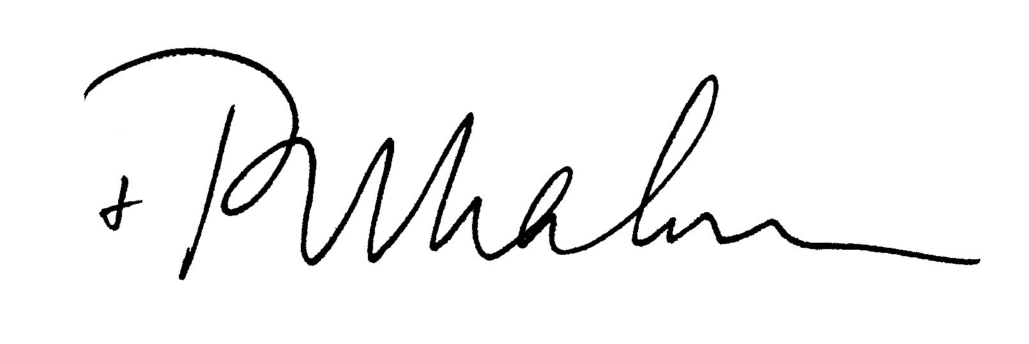

The American Cathedral of the Holy Trinity 23 av. George V, 75008 Paris, France
Tel. (33-1) 53 23 84 06 Fax (33-1) 49 52 96 85
Email: office@tec-europe.org

The word “marriage” as used here applies to a covenanted relationship, in countries that do not allow same-sex marriage. The rite of blessing a union is allowed only in those countries; otherwise one of the trial rites of marriage approved by General Convention 2015 must be used.

